**A Project Report**

**on**

**Yummy Kitchen Hub**

Submitted in partial fulfilment of the requirements of

Project-IV(BIT256C0)

of

Bachelor of Information Technology

**Submitted To**



Purbanchal University

Biratnagar, Nepal

**Submitted By**

Dhiraj Sapkota (345404)

Elisha Rai (345405)

Sagar Upadhyaya (345419)

**KANTIPUR CITY COLLEGE**

Putalisadak, Kathmandu

11 September 2023

**A Project Report**

**on**

**Yummy Kitchen Hub**

Submitted in partial fulfilment of the requirements of

Project-IV(BIT256C0)

of

Bachelor of Information Technology

**Submitted To**

Purbanchal University

Biratnagar, Nepal

**Submitted By**

Dhiraj Sapkota (345404)

Elisha Rai (345405)

Sagar Upadhyaya (345419)

**Project Supervisor**

Mr. Kiran Khanal (Professor)

**KANTIPUR CITY COLLEGE**

Putalisadak, Kathmandu

11 September 2023

Table of Content

Chapter 1: Introduction 1

1.1 Overview 1

1.2 Problem Statement 1

1.3 Objectives 2

1.4 Features 2

1.5 Significance 3

1.6 Scope and Limitation 3

1.6.1 Scope 3

1.6.2 Limitation: 4

Chapter 2: Literature Review 5

Chapter 3: Methodology 7

3.1 Software Development Life Cycle 7

3.2 Technologies and Tools 9

3.2.1 Specified Programming Language 9

3.2.2 Specified Database 9

3.2.3 Specified Software 9

3.3 Assignments of Rolls and Responsibilities 9

Chapter 4: System Analysis 10

4.1 Requirement Analysis 10

4.1.1 Requirement Gathering 10

4.1.2 Functional Requirement 11

4.2 Feasibility study 12

4.2.1 Technical Feasibility 12

4.2.2 Economic Feasibility 12

4.2.3 Schedule Feasibility 12

4.2.3.1 Gantt chart 13

Chapter 5: System Design 14

5.1 System Architecture 14

5.2 Data Flow diagram 15

5.2.1 Context Level (level 0) DFD: 15

5.2.2 Level 1 DFD: 16

5.2.3 Use Case Diagram: 17

5.3 Database Design 18

5.3.1 ER Diagram 18

5.3.2 Data Dictionary 19

Chapter 6: System Development and Implementation 20

6.1 Programming Platform 20

6.2 Operating Environment 20

Chapter 7: Testing and Debugging 21

7.1 Tools use in testing 21

7.2 Test Cases 22

Chapter 8: Conclusion 24

Chapter 9: Future Enhancement 25

Chapter 10: References 26

APPENDIX 27

# **List of figures**

Fig 3.1: Waterfall model……………………………………………………….7

Fig 5.2.1: Level 0 DFD…………………………………………………….….14

Fig 5.2.2: Level 1 DFD………………………………………………….…….15

Fig 5.2.3: Use Case Diagram ……………………………………….………...16

Fig 5.3.1: E-R Diagram……………………………….……………………….17

## **List of tables**

Table 3.3: Assignments of Rolls and Responsibilities……….………….….…...9

Table 4.1.1: Requirement Gatherings…………………………………….…....10

Table 4.1.2: Functional Requirements………………………………………….11

Table 4.2.3.1: Gantt chart…………………………………………….……. ….13

Table 5.3.2: Data Dictionary……………………………………………. ….…18

Table 7.1: Tools use in Testing……………………………………….….…….20

Table 7.2.1: Test case login……………………………………………...….…21

Table 7.2.2: Test case Admin…………………………….…….……………….21

Table 7.2.3: Test case Staff……………………………………………….…….22

# **TOPIC APPROVAL SHEET**

It is here by informed that the topic selected by Dhiraj Sapkota, Elisha Rai and Sagar Upadhyaya of BIT IV semester project has been found suitable and as per the credit assigned by Purbanchal University (PU), Biratnagar, Nepal. The Project Committee has approved the following topic and supervisor for the mentioned students. This project has been completed for the prescribed period and the project embodied the result of their investigation conducted while they worked as full-time students of this institution.

Topic Approved: Yummy Kitchen Hub

Mr. Saroj Pandey Mr. Kiran Khanal

HOD, Department of IT Project Supervisor

Kantipur City College

# **CERTIFICATE FROM THE SUPERVISOR**

This is to certify that the project entitled Yummy Kitchen Hub submitted by Dhiraj Sapkota, Elisha Rai and Sagar Upadhyaya to the Department of Information Technology, School of Science and Technology at Kantipur City College, Putalisadak, Kathmandu towards the requirement for BIT: Project-IV is an original work carried out by them under my supervision and guidance.

_______________________________

Mr. Kiran Khanal

Department of Information Technology

Kantipur City College

(Project Supervisor)

# **Acknowledgement**

We are very grateful to submit this project report. This report wouldn’t have been possible without the immense contribution of a few people. Firstly, we would like to express our deepest gratitude to Purbanchal University for providing us with this opportunity to present this project and its report.

We would like to express our gratitude and deep respect to our respected project supervisor Mr. Kiran Khanal who helped us solve any problems that arose during the preparation of this project.

Lastly, we want to thank Kantipur City College for providing us with this opportunity by approving our project. We are thankful to our dear friends for constant support and encouragement, and we would like to thank our seniors as well who helped us out while we were stuck at a problem during the development of our project. We hope that this project will fulfill the course requirement.

With regards

Dhiraj Sapkota

Elisha Rai

Sagar Upadhyaya

# **Abstract**

Yummy Kitchen Hub presents an efficient restaurant management system tailored to enhance operational effectiveness in the food service industry. This project focuses on optimizing core processes, including table management, order placement, and billing designed for seamless utilization by both staff and administrators. The table management feature empowers staff and administrators to effortlessly oversee table assignments and availability, reducing wait times and ensuring efficient seating arrangements. Through an intuitive interface, the system enables real-time updates on table status.

Order placement is facilitated through an intuitive interface that empowers staff to efficiently manage customer orders. Billing becomes a streamlined process with the integration of this restaurant management system. Staff can swiftly generate accurate bills based on order details, reducing errors, and expediting the checkout process. This not only enhances customer satisfaction but also aids in the efficient management of financial transactions. With a primary focus on staff and administrative users, the system limits customer interactions to menu viewing. Customers can access the menu items without engaging in the online ordering process, preserving the traditional dining experience while benefitting from a digital menu display.

Incorporating these features, the Yummy Kitchen Hub presents a targeted approach to enhancing restaurant operations. By catering to staff and administrative needs while offering customers an intuitive menu interface, this system aims to elevate the efficiency, accuracy, and overall dining experience within the restaurant.

# **Chapter 1: Introduction**

The project Yummy Kitchen Hub is a desktop application which we have developed to streamline the operations of a restaurant. It provides a comprehensive solution for managing various aspects of a restaurant, including menu management, order placement, table management, sales report, and billing.

Menu management in a Yummy Kitchen Hub allows for easy customization and making it simple to update. Order placement features enable efficient, error-free order taking and enhance customer service. Billing capabilities calculate accurate totals, offer split bills, and help to generate order reports. Table status tracking ensures optimal seating allocation, making it a valuable tool for efficient restaurant operations.

## **Overview**

In today's fast-paced world, the restaurant industry demands efficient management solutions to cater to the growing demands of customers while maintaining a high level of service quality. Yummy Kitchen Hub addresses these needs by offering a digital platform that simplifies the entire dining process. By integrating various functions such as menu management, order placement, staff interaction, and administrative control, the system optimizes restaurant operations and enhances customer satisfaction.

## **1.2 Problem Statement**

* Quantity and price determination in order placement
* Failed to track sales report.
* Table status and bill generation.

## **1.3 Objectives**

* To provide efficient management of restaurant operations which includes:
* menu
* Order
* Billing
* Table
* Report

## **1.4 Features**

* + Staff and Admin login
* Menu management
* Food order placement
* Billing
* Managing table
* Sales report

## **1.5 Significance**

A Yummy Kitchen Hub plays a pivotal role in the contemporary restaurant industry, wielding significant influence over the efficiency, customer service quality, and overall success of dining establishments. This multifaceted software solution brings efficiency to a variety of critical functions, including order processing, table allocation, and employee management. By streamlining these operations, Yummy Kitchen Hub boost productivity, minimizes errors, and reduces wait times, ultimately leading to improved customer satisfaction and loyalty.

Moreover, the ability to easily update menus, track sales, and manage employees empowers restaurant owners to maintain proper business growth. In essence is not just a tool; it's the backbone of modern restaurant management, facilitating efficient, data-driven decision-making and helping establishments thrive in an ever-evolving industry. Top of Form

## **1.6 Scope and Limitation**

### 1.6.1 Scope

Our Yummy Kitchen Hub system encompasses three key components: efficient bill generation, streamlined order management, and effective table allocation. It simplifies the billing process, minimizes order errors, and optimizes table seating, ultimately enhancing customer satisfaction and operational efficiency for dining establishments.

The project's goal is to empower restaurant owners and staff with a comprehensive toolset to streamline operations, enhance customer service, and improve overall efficiency. The system aims to simplify daily tasks, reduce errors, and provide valuable insights for better decision-making. Ultimately, Yummy Kitchen Hub seeks to elevate the dining experience and contribute to the success of dining establishments in the modern restaurant industry.

### 1.6.2 Limitation:

* Offline mode
* Lacked inventory management.
* No customer interaction
* Profit calculation excluded.

# **Chapter 2: Literature Review**

We looked at various research papers and projects to understand all the previous work done on the project we undertook.

* These studies emphasize the need for efficient management of different aspects of restaurant operations, including order management, table management, billing, sales report, and user authentication.
* Java-based restaurant management systems have been found to offer a range of benefits, such as improved order accuracy, reduced order processing time, better billing mechanisms, enhanced reporting, and increased customer satisfaction.
* First, research was done on a website named: Restaurant management system. Within this website, there are the following features: Staff Management, Login Admin, Stock Control, and Menu Management.

**Pros:**

* Authentication
* User control

**Cons:**

* Technical issues
* Complexity
* Table management issue
* We studied available restaurant management system in Nepal there are many systems, but we research about “Touch Bistro” it comes with mobile functionality, advanced management capability and food service specific features to meet unique needs of the restaurant industry.

**Pros:**

* Easy bill splitting
* Offline mode
* Reporting and analytics

**Cons:**

* Expensive
* Device incompatible
* We studied and experienced our college canteen management system. There is no well-managed system, manually they write order on the copy and occupied by ticket to the students. We noticed this problem is the biggest problem, there is a lack of time efficiency, seating problems, billing problems. To solve this problem, we decided to work on this project.

**Pros:**

* Easy to work.

**Cons:**

* Lacked time efficiency.
* Food order placement problem
* No accuracy on billing system

# **Chapter 3: Methodology**

## **3.1 Software Development Life Cycle**

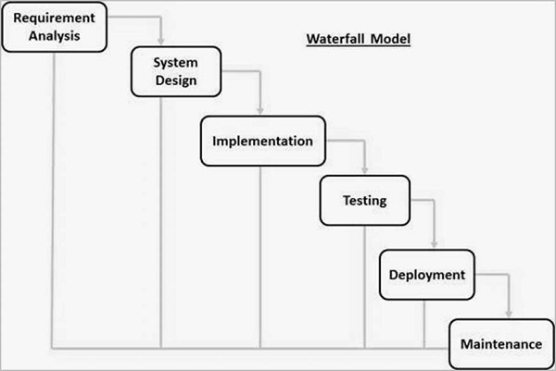The Waterfall Model is one of the earliest and most traditional approaches to software development. It was first introduced by Dr. Winston W. Royce in a paper published in 1970. The Waterfall Model is a linear and sequential approach that divides the software development process into distinct phases, each of which must be completed before moving on to the next. We have used waterfall model to work on this project Yummy Kitchen Hub is the shortest period or one semester project, it is a small project and requirement are predefined as well as we don’t need to move back so we have chosen it as the best model for our project.

Fig 3.1: Waterfall Model

1. Requirements Gathering and Analysis:

In this initial phase, we all development team gathered and documented all the project requirements. Detailed analysis of the requirements is performed to ensure a clear understanding of the “Yummy Kitchen Hub” scope and objectives.

1. System Design:

Once the requirements are well-defined, the system design phase begins. In this phase, we designed an overall blueprint of system design. Make an entity-relationship diagram to describe relationships between entity and discussed about attributes of each entity, and design Dataflow Diagram (DFD) to understand flow of data.

1. Implementation (Coding):

In this phase, we started coding based on the design specifications. The code is written and reviewed to ensure it aligns with the design and meets the specified requirements.

1. Testing:

After coding, we are entering the testing phase. We conducted various tests, including unit testing, integration testing, system testing, and user acceptance testing, to identify and rectify defects. Each test is successfully run, after rectifying and debugging errors.

1. Maintenance:

The maintenance phase is the last stage of the waterfall model, where we monitor, update, and fix it after it is released to the users. In this phase we can work as an activity such as bug fixing, performance improvement, security enhancement, and feature addition.

## **3.2 Technologies and Tools**

Yummy Kitchen Hub is a java-based restaurant management system. In this project we are using various tools and technologies.

### 3.2.1 Specified Programming Language

Programming language: Java

### 3.2.2 Specified Database

Database: MySQL

### 3.2.3 Specified Software

Software: IntelliJ Idea

## **3.3 Assignments of Rolls and Responsibilities**

The member assigned with these responsibilities:

|  |  |
| --- | --- |
| **Team Members** | **Task Performed** |
| Dhiraj Sapkota | Requirement Gathering, Coding & Documentation |
| Elisha Rai | System Analysis & Design, Documentation, Debugging |
| Sagar Upadhyaya | System Analysis & Design, Coding & Debugging |

Table 3.3: Assignments of Rolls and Responsibilities

# **Chapter 4: System Analysis**

## **4.1 Requirement Analysis**

The Yummy Kitchen Hub restaurant management system requires user authentication and authorization, with separate logins for admin and staff, ensuring access restrictions based on user roles. Employee management features empower the admin to register new employees, capturing personal and job-related information. Sales analysis capabilities allow staff to report sales data, enabling the admin to analyze sales reports and generate customizable reports for specific date ranges. Menu management enables the admin to add, edit, or remove menu items, each with essential details like name, quantity, and price. Table management features empower staff to assign tables, monitor availability, and track statuses. Order management allows staff to take customer orders, modify them as needed, and view menu items with descriptions. Billing and payment functionalities facilitate bill generation based on orders and calculate the total amount. Lastly, menu item viewing is accessible to both staff and customers, providing details like item names, descriptions, and prices.

### 4.1.1 Requirement Gathering

|  |  |
| --- | --- |
| Requirement Name | Description |
| Authentication and authorization | Staff and admin access the system by using username, and password |
| Menu management | Admin (owner) modified the menu item |
| Billing and payment | Bill generated and reported by admin |
| Table management | Track table availability and status |
| Order placement | Serve the food item appropriately |

Table 4.1.1: Requirement Gatherings

### 4.1.2 Functional Requirement

|  |  |
| --- | --- |
| **Function Name** | **Description** |
| Menu info | View the item details |
| Admin page | It consists of item modification, staff modification, and view order report |
| Staff page | It consists of order placement, view menu info |
| Staff/admin login | Performed authentication |
| Staff info | Manages staff details |
| Order placement | Take order and it is added to the orders database, bill generate and show table status |
| Home page | It consists of admin page, staff page, customer page |
| Customer page | Customer able to view menu item |
| Sales report | Track total amount earned according to date |

Table 4.1.2: Functional Requirement

## **4.2 Feasibility study**

### 4.2.1 Technical Feasibility

The technical feasibility study suggests that implementing a Restaurant Management System using Java and MySQL Server is viable, provided that the necessary hardware, software, and development resources are available. Thorough planning and adherence to best practices in software development and database management are crucial for the success of the project. Additionally, ongoing maintenance and support are essential to ensure the long-term sustainability of the system.

Yummy Kitchen Hub is a restaurant management system. It is a java-based desktop application. This project is technically feasible to develop and use. We can use a java development kid version 11.6, and IntelliJ idea IDE is used to coding the program. Database is the most crucial thing for each application to store, process, retrieve, and access the data. We are using MySQL database server for database.

### 4.2.2 Economic Feasibility

This economic feasibility study evaluates the viability of developing and implementing a Restaurant Management System (RMS). The RMS aims to streamline restaurant operations, enhance customer service, and improve overall efficiency. This study assesses the financial aspects of the project to determine its economic feasibility.

We are estimating development costs, including software development, and hardware acquisition. Calculate ongoing expenses such as maintenance, licensing, and support. All the estimation is feasible for our management system.

### 4.2.3 Schedule Feasibility

Assessing the schedule feasibility for the development of a restaurant management system is essential to ensure that the project can be completed within the allotted timeframe. The feasibility analysis considers a range of critical factors, including the complexity of the system, the availability of resources, and the scope of work. It's crucial to consider the various phases of the project, from planning and design to development, deployment, and ongoing maintenance. Additionally, evaluating the project's dependencies, potential risks, and historical data from similar projects can help in determining whether the proposed schedule is realistic and achievable.

We have six months’ time to complete all the system so, each process or phase is feasible to schedule on timeframe. Our analysis is succeeding, and we completed all the tasks in setting schedule.

### 

### 4.3.2.1 Gantt chart

*Table 4.2.3.1: Gantt chart*

Table 4.2.3.1: Gantt chart

# **Chapter 5: System Design**

## **5.1 System Architecture**

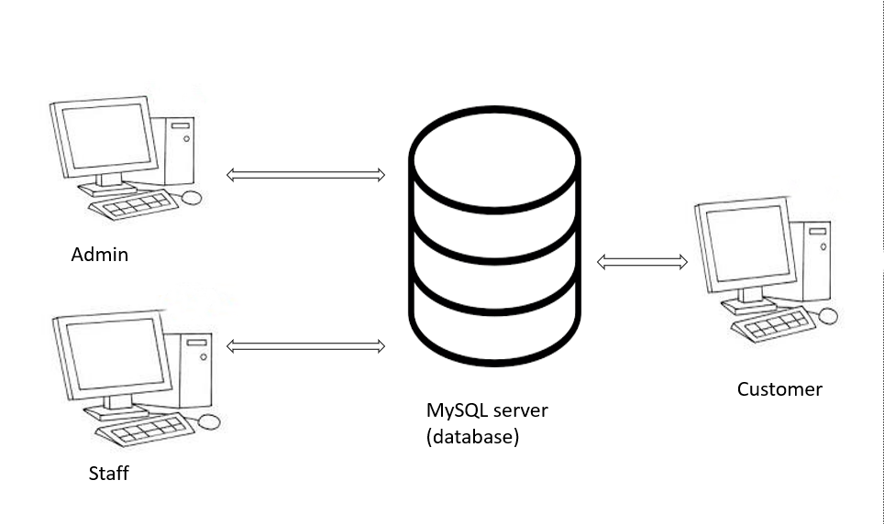

Fig 5.1: System Architecture

## **5.2 Data Flow diagram**

A data-flow diagram is a way of representing a flow of data through a process or a system. The DFD also provides information about the outputs and inputs of each entity and the process itself.

### 5.2.1 Context Level (level 0) DFD:

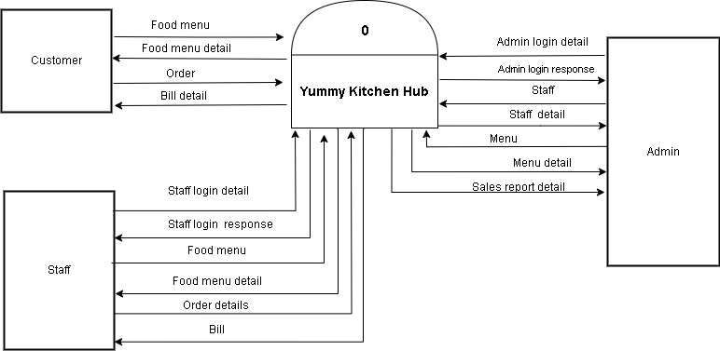

Fig 5.2.1: Level 0 DFD

### 5.2.2 Level 1 DFD:

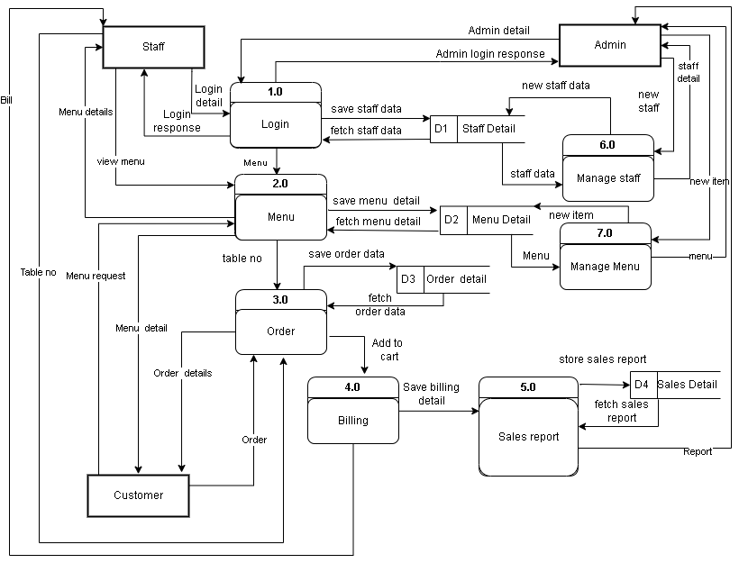

Fig 5.2.2: Level 1 DFD

### 5.2.3 Use Case Diagram:

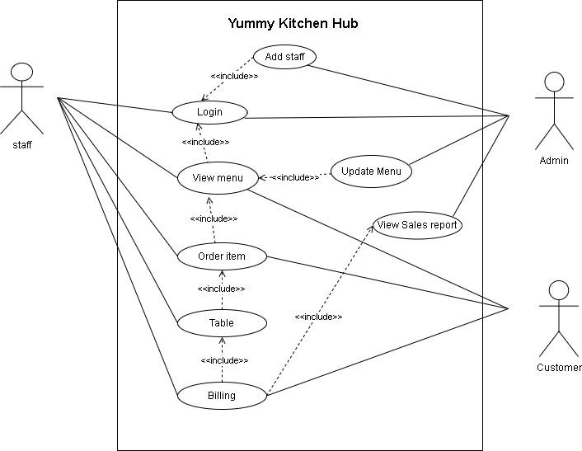

Fig 5.2.3: Use Case Diagram

## **5.3 Database Design**

### 5.3.1 ER Diagram

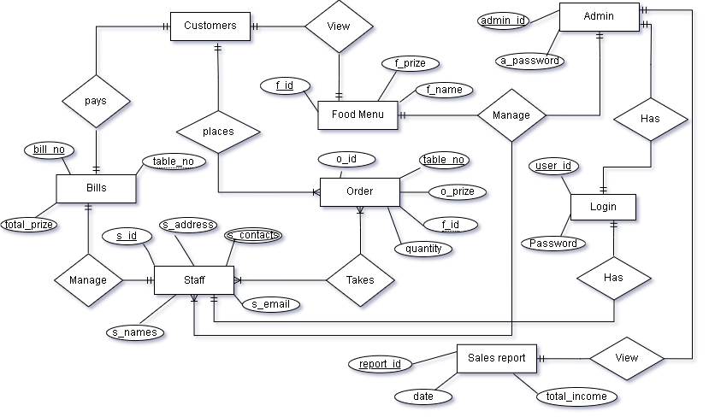

Fig 5.3.1: E-R Diagram

### 5.3.2 Data Dictionary

|  |  |  |  |  |
| --- | --- | --- | --- | --- |
| **Table Name** | **Field Name** | **Data Type** | **Field size** | **Description** |
| Food | f-name | Varchar | 40 | Food name |
| Food | f-price | double |  | Food price |
| Food | Quantity | int |  | Food quantity |
| Food | f-id | int |  | Food id (Primary key) |
| Admin | A-name | varchar | 35 | Admin name |
| Admin | A-id | int |  | Admin id (Primary key) |
| Staff | S-name | varchar | 35 | Staff name |
| Staff | S-id | Int |  | Staff id (Primary key) |
| Orders | f-id | int |  | Food id (Foreign key) |
| Order Report | Order-id | int |  | Order id (Foreign key) |
| Order Report | Table-number | int |  | Order table number |
| Order Report | Total-amount | double |  | Order total amount |
| Orders | Order-id | int |  | Order id (Primary key) |

Table 5.3.2: Data Dictionary

# **Chapter 6: System Development and Implementation**

## **6.1 Programming Platform**

We are using IntelliJ idea IDE for programming. IntelliJ IDEA provides [support for developing](https://www.jetbrains.com/idea/jakarta/) enterprise Java applications based on [Jakarta EE](https://jakarta.ee/) (formerly known as Java EE). All the required plugins are bundled and enabled by default in IntelliJ IDEA Ultimate. The main plugin is Jakarta EE Platform for the core platform support, such as a dedicated project wizard. Other plugins that start with Jakarta EE in their name add support for various specifications, such as JPA, JAX-RS, and so on.

## **6.2 Operating Environment**

Software Specifications

Computer software specification we have used for development:

* Operating System: Windows 10 Operating System
* IntelliJ Idea
* MySQL database Server

Hardware Specifications

Computer hardware specification we have used for development:

* Processor: Intel Core i5
* RAM: 8GB
* SSD: 512GB

# **Chapter 7: Testing and Debugging**

Testing and debugging are crucial phases in the software development process to ensure that the system works correctly and is free of errors or bugs. We are testing a step-by-step guide on how to approach testing and debugging systems effectively. We tested the overall system, unit system, performance of system, debugging, security testing, and code review.

|  |  |  |
| --- | --- | --- |
| **S. N** | **Tools** | **Specification** |
| 1 | Laptop | Hardware |
| 2 | IntelliJ | IDE |
| 3 | MySQL | Database server |

## **7.1 Tools use in testing**

Table 7.1: Tools use in Testing

## **7.2 Test Cases**

|  |  |  |  |  |  |
| --- | --- | --- | --- | --- | --- |
| **Test Case Login** | | | | | |
| **ID** | **Test case description** | **Test case data** | **Expected result** | **Actual result** | **Status** |
| 01 | authenticate admin login system | Username, password | login | login | success |
| 02 | Authenticate staff login system | Username, password | login | login | success |

Table 7.2.1: Test case login

|  |  |  |  |  |  |
| --- | --- | --- | --- | --- | --- |
| **Test Case Admin** | | | | | |
| **ID** | **Test case description** | **Test case data** | **Expected result** | **Actual result** | **Status** |
| 01 | Register new staff | Staff details | registered | registered | success |
| 02 | View sales report | Sales item, f-price, date | viewed | viewed | success |
| 03 | Modify menu item | Name, price, category | modified | modified | success |

Table 7.2.2: Test case admin

|  |  |  |  |  |  |
| --- | --- | --- | --- | --- | --- |
| **Test Case Staff** | | | | | |
| **ID** | **Test case description** | **Test case data** | **Expected result** | **Actual result** | **Status** |
| 01 | Staff verify table status | table no. | Verified | Verified | success |
| 02 | Order placement | f-name, f-qty, f-price | served | served | success |
| 03 | Add to cart | f-name, f-qty, f-price | added | added | success |
| 04 | Bill generates | Table no, order-item | generated | generated | success |
| 05 | Mark as paid | Table no., total bill amount | paid | paid | success |

Table 7.2.3: Test case staff

# **Chapter 8: Conclusion**

This Java-based desktop application has successfully addressed various challenges faced by restaurants in managing their day-to-day activities. With its comprehensive set of features, including menu management, order placement, billing, and sales reporting, it has greatly enhanced the efficiency and effectiveness of restaurant operations.

This project was undertaken with the primary objective of streamlining and optimizing restaurant management processes. Through meticulous design and development, we have created a user-friendly, reliable, and efficient system that meets the diverse needs of restaurant owners, managers, and staff.

The Menu Management feature allows for easy customization and updates, ensuring that restaurants can adapt to changing customer preferences and dietary requirements swiftly. The Order Placement module simplifies the ordering process, reducing errors and improving customer satisfaction. The Billing system provides accurate and efficient financial management, while the Sales Report feature offers valuable insights into strategic decision-making.

The success of the Yummy Kitchen Hub is a testament to the dedication, teamwork, and technical expertise of our project members. It not only serves as a powerful tool for restaurant owners but also contributes to the broader restaurant industry's evolution towards more efficient and customer-centric operations.

As technology continues to play a vital role in the restaurant business, we believe that our application will continue to be an asset, helping restaurants thrive. We remain committed to enhancing and expanding the system's capabilities to meet the ever-evolving needs of the restaurant industry.

# **Chapter 9: Future Enhancement**

* Online mode enhancement
* Inventory management integration
* Customer interaction features
* Profit calculations inclusion

# **Chapter 10: References**

* Bhuvaneshvari, K. (2022, November 27). Restaurant Management System Project in Java - Copy Assignment.

*Copy Assignment*. https://copyassignment.com/restaurant-management-system-project-in-java/

* Lovelycoding.org. (2023, February 20). *Restaurant Management System Project for Final Year*. LovelyCoding.org. https://www.lovelycoding.org/resturant%20management-system/
* Delta Tech - software company based in Nepal. (n.d.). *Restaurant Management Software in Nepal | Restaurant POS*. Delta Tech. https://deltatechnepal.com/business-apps/restaurant-management-system

# No description available.**APPENDIX**

Fig: Opening page

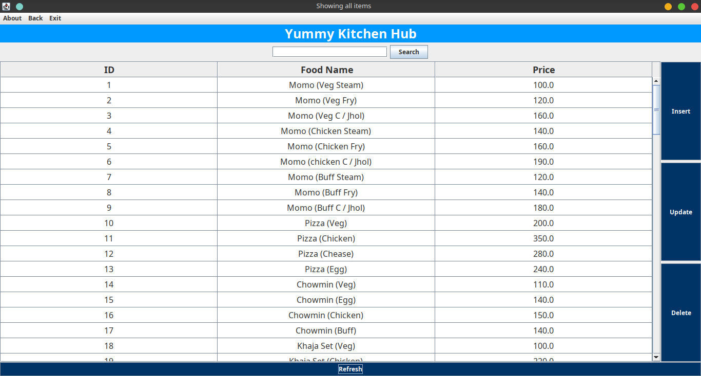

Fig: Menu

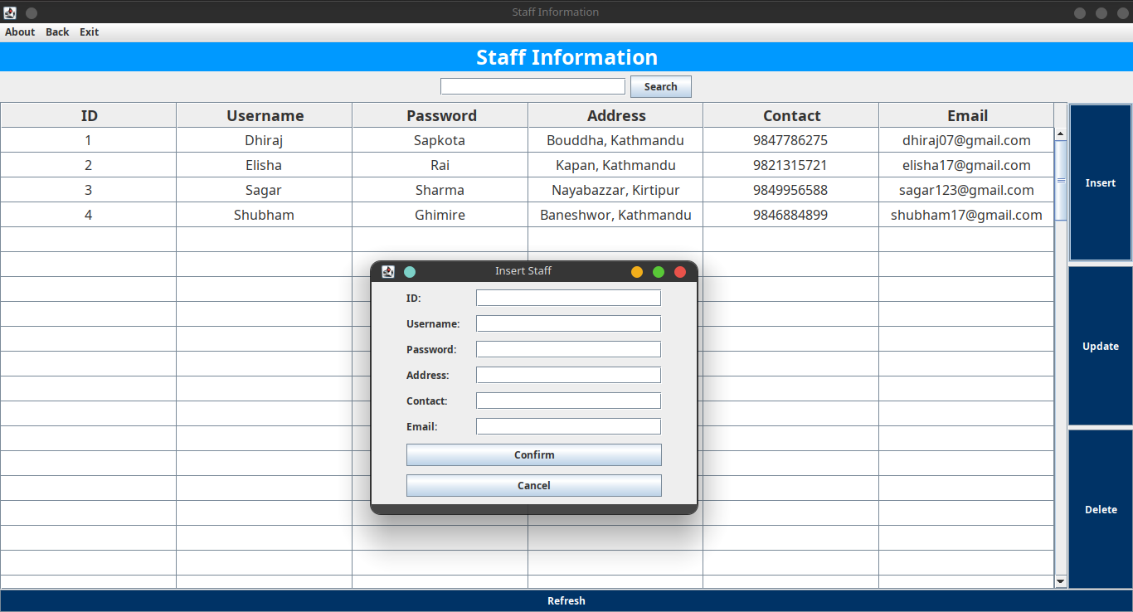

Fig: Staff Page

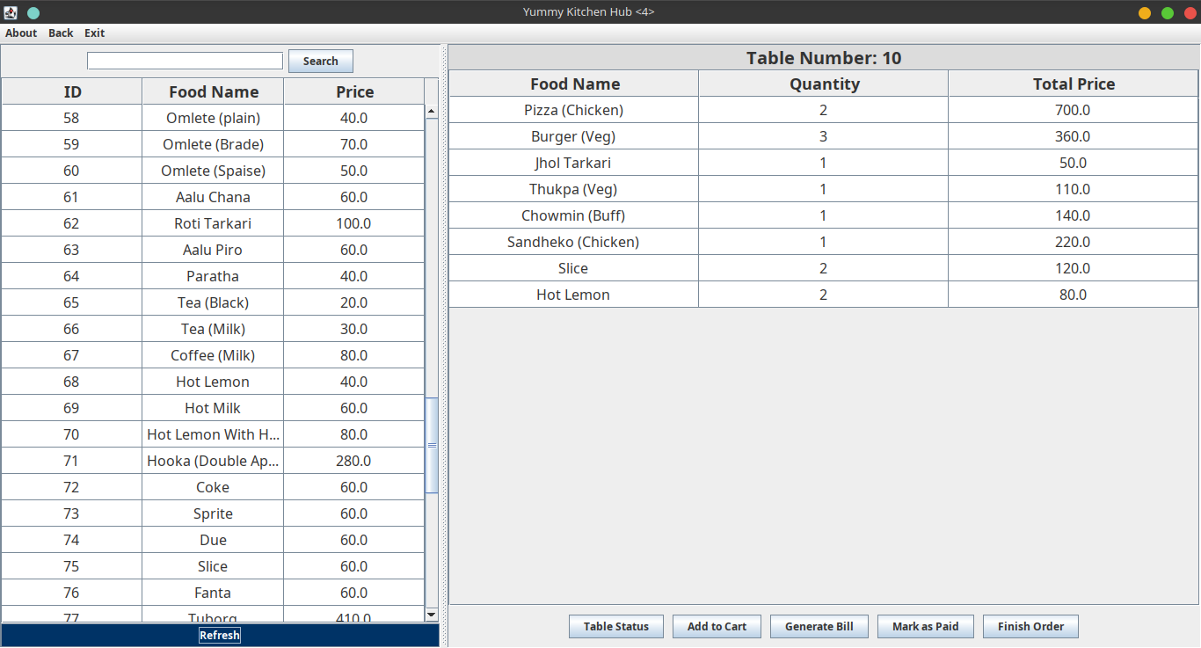

Fig: Order page

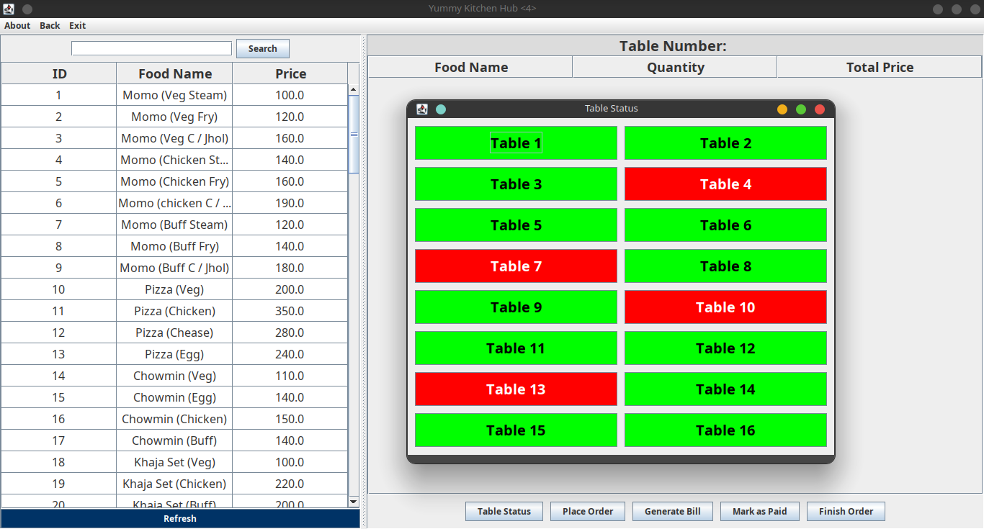

Fig: Table status

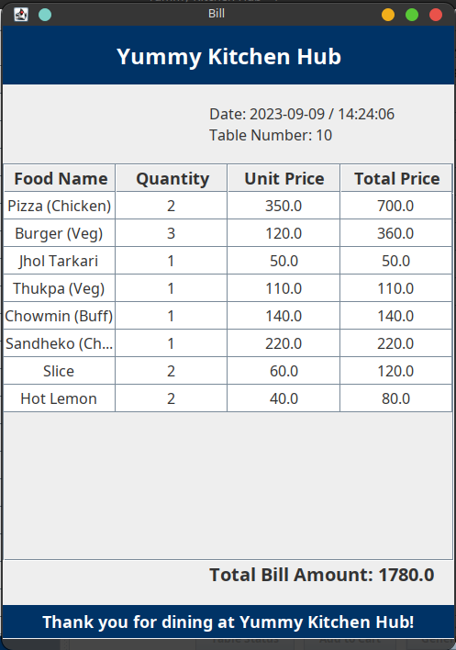

Fig: Bill